KB ENGINEERING COATINGS SDN. BHD.

(Co. No: 831283D)

No. 22 Jalan TS 6/9, Taman Industri Subang, 47510 Subang Jaya,

Selangor Darul Ehsan. Tel: 03-56215266 Fax: 03-56215266

GST Reg. No. 001438527488

**Sample Job before and after repair (Thermal spray, welding and Laser welding)**

1. **Homogenize plunger** **repair by HVOF process**

After

Before

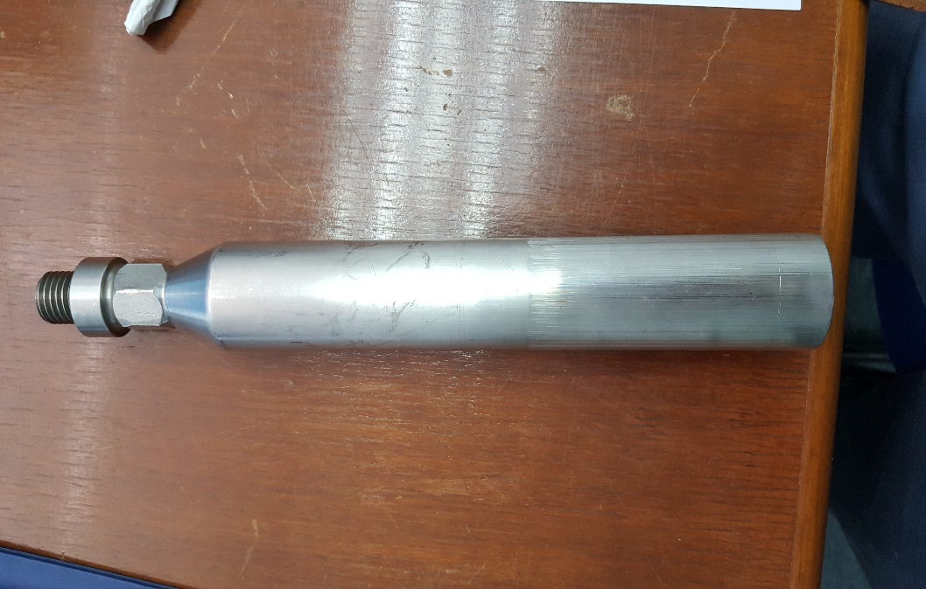

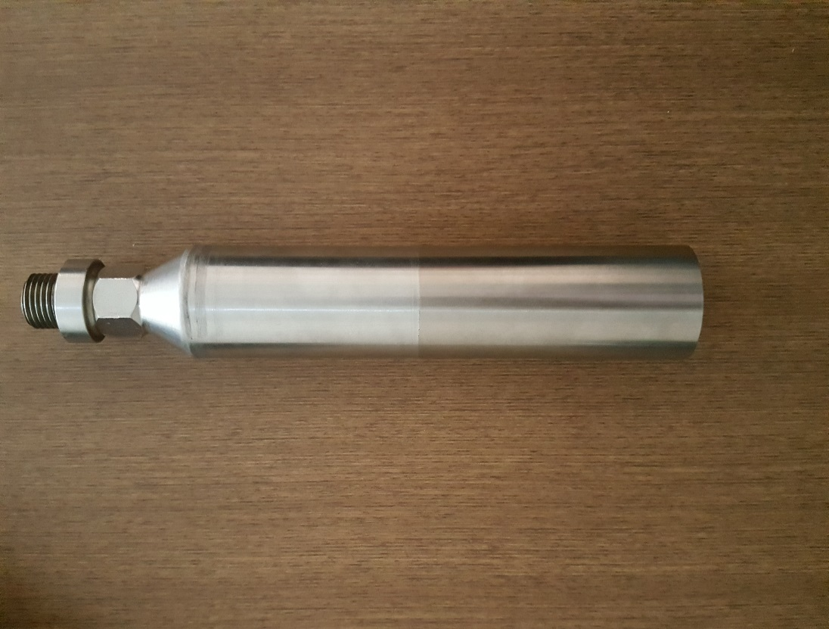

**2. Needle Repair (flow control for Pelton Turbine)**

**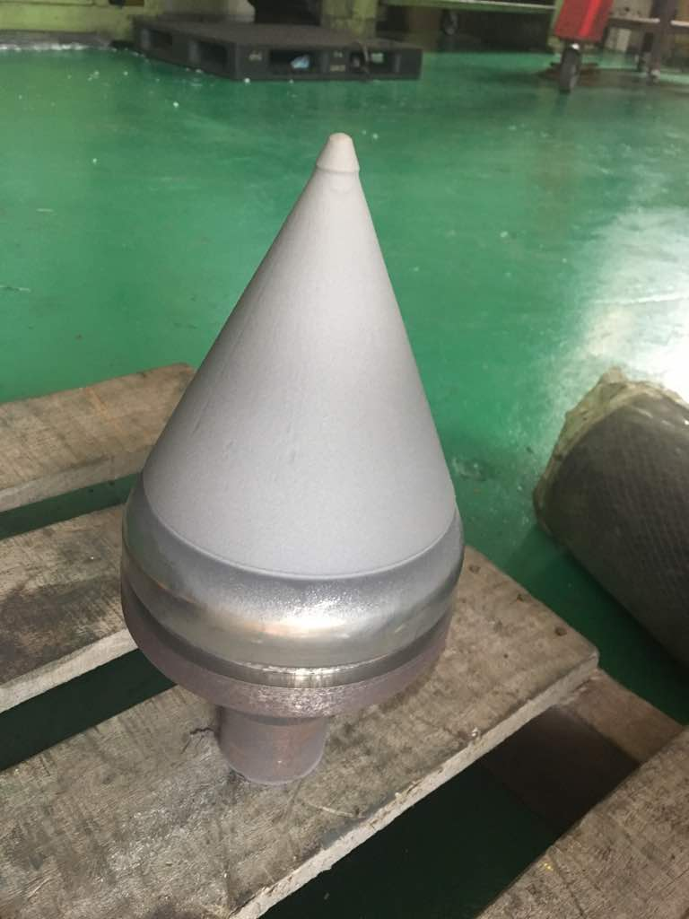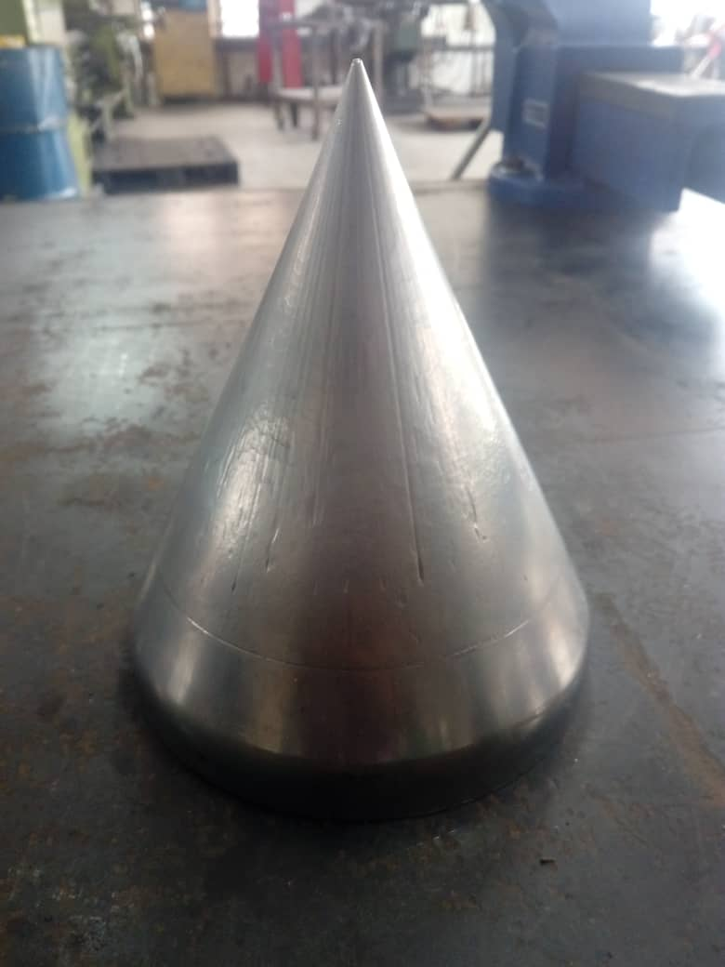**

Before

After spray

**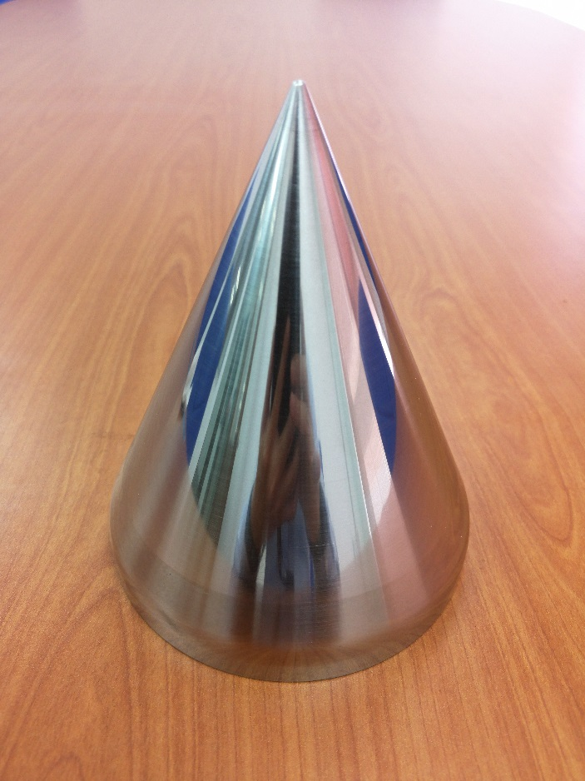**

Completed job

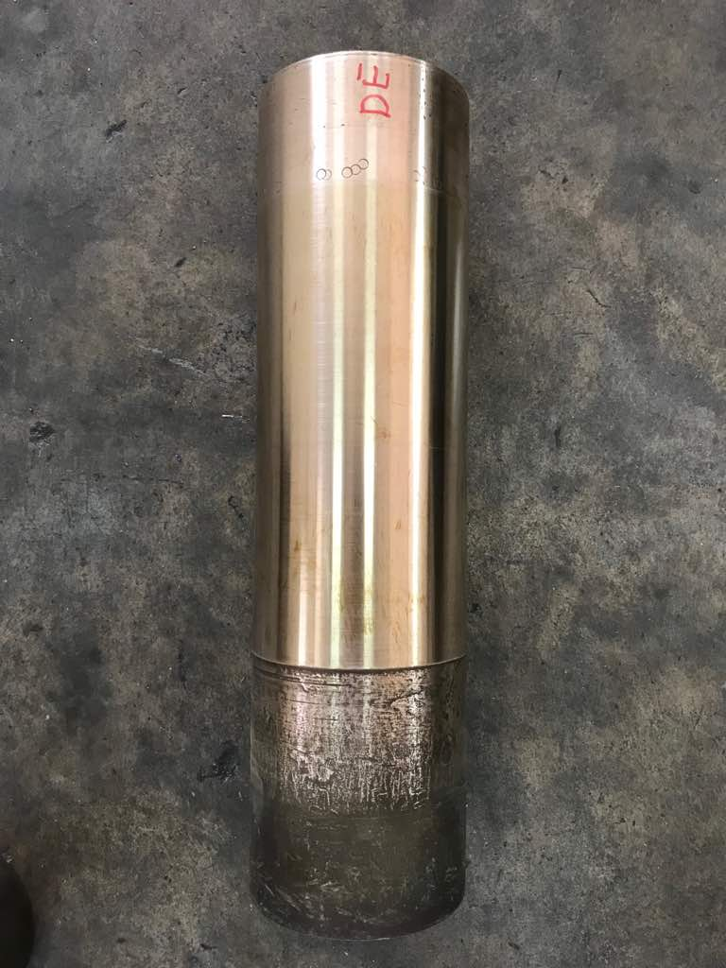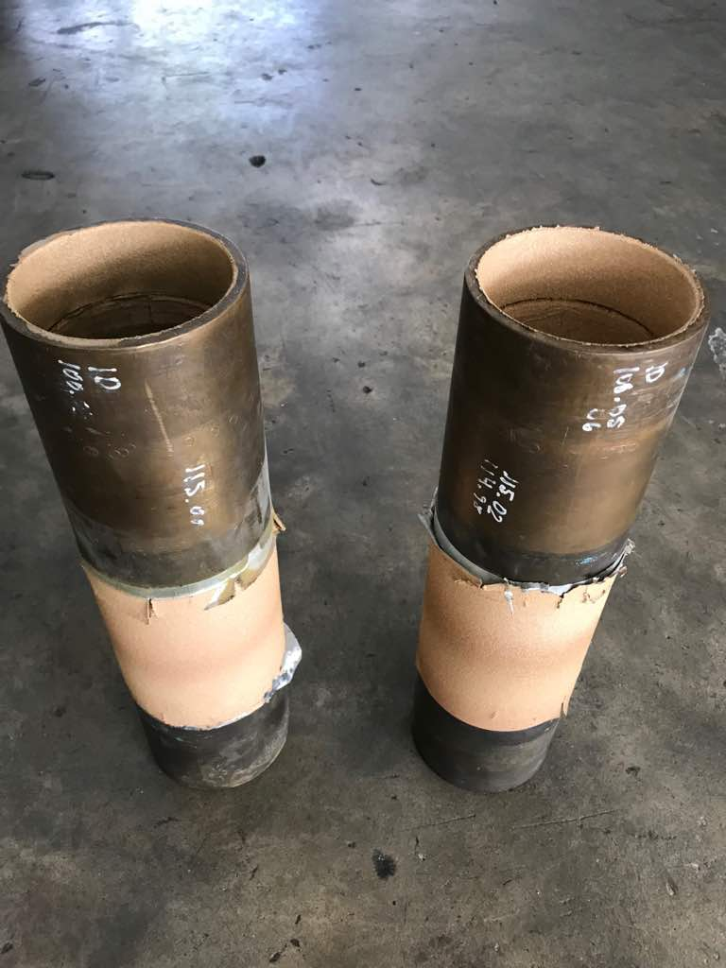

Aluminium Bronze Sleeve DE and NDE after metal spray and machining.

Repair of Aluminium Bronze Sleeve for Mech Seal Area by Arc spray process.

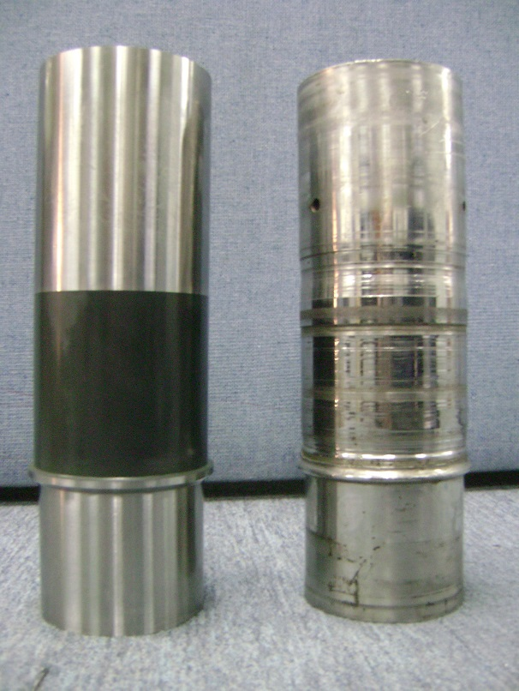

Repairing of packing sleeve

With Ceramic Coatings.

|  |  |
| --- | --- |
| D:\Documents_Backup\Photos-Jobs done\Tasek Haza _ Dato\WIER PUMP 2018 Mar\New folder\WhatsApp Image 2018-03-27 at 22.44.31(1).jpeg | D:\Documents_Backup\Photos-Jobs done\Tasek Haza _ Dato\WIER PUMP 2018 Mar\New folder\WhatsApp Image 2018-03-27 at 22.47.40(1).jpeg  Repair by welding material Cast iron. |

Worn outlet of Pump

|  |  |
| --- | --- |
| D:\Documents_Backup\Photos-Jobs done\Tasek Haza _ Dato\WIER PUMP 2018 Mar\New folder\WhatsApp Image 2018-03-27 at 22.35.23.jpeg | D:\Documents_Backup\Photos-Jobs done\Tasek Haza _ Dato\WIER PUMP 2018 Mar\New folder\WhatsApp Image 2018-03-27 at 22.35.07.jpeg |

After welding repair and coated with ceramic polymer compound.

Applying Ceramic Polymer

Compound after welding

1.To repair pump body case wear ring seat area by machining and removing the old weld.

2.To fabricate cast iron insert to fit machined case Wear ring seat area

|  |  |  |
| --- | --- | --- |
| D:\Documents_Backup\Photos-Jobs done\Tasek Haza _ Dato\WIER PUMP 2018 Mar\New folder\WhatsApp Image 2018-03-29 at 11.30.24.jpeg | | D:\Documents_Backup\Photos-Jobs done\Tasek Haza _ Dato\WIER PUMP 2018 Mar\New folder\WhatsApp Image 2018-03-27 at 22.24.44.jpeg |
|  | |  |
| D:\Documents_Backup\Photos-Jobs done\Tasek Haza _ Dato\WIER PUMP 2018 Mar\New folder\WhatsApp Image 2018-03-29 at 11.30.24(1).jpeg | The previously welded area to  be machine of and replace  with Cast Iron insert. | |

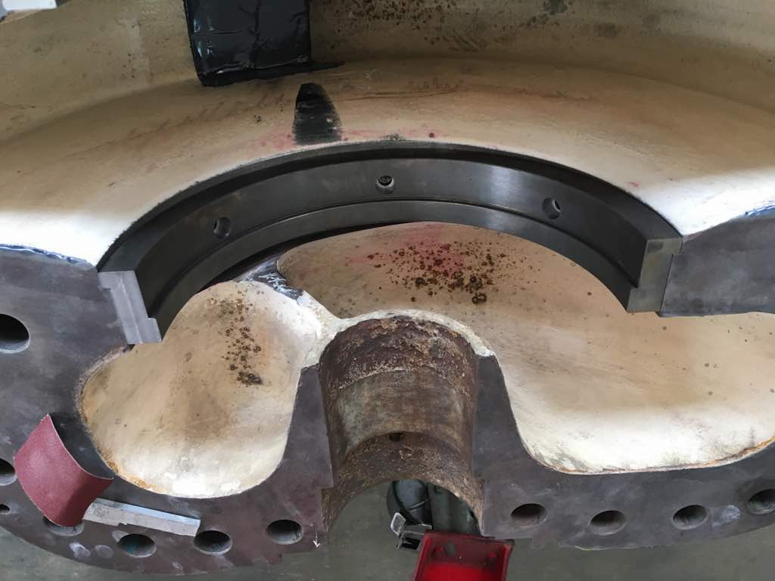

Cast Iron Insert machined and install into Pump Body Case Wearing Area

**Pump Shaft**

**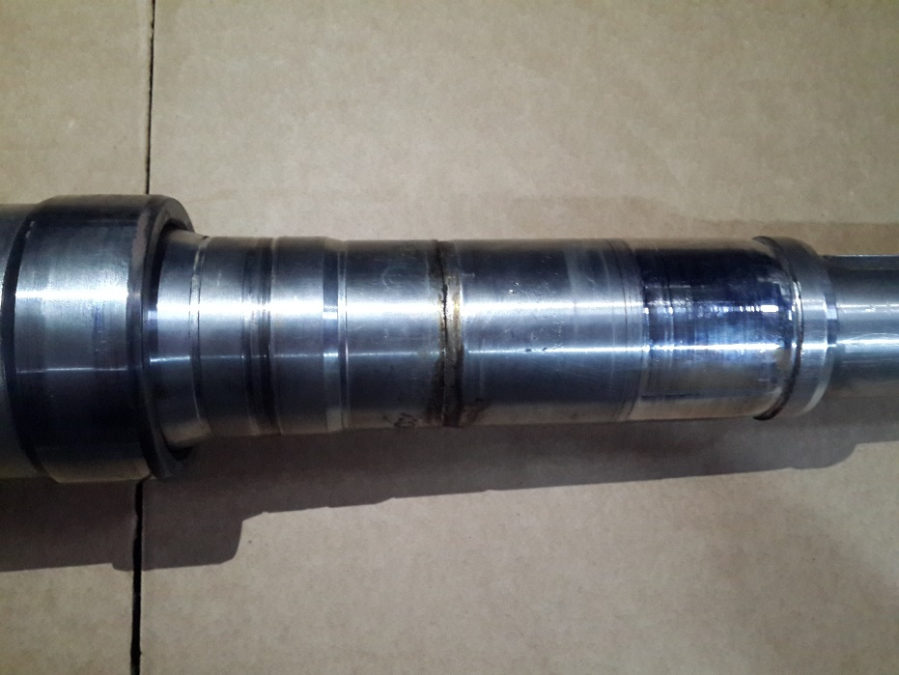**

**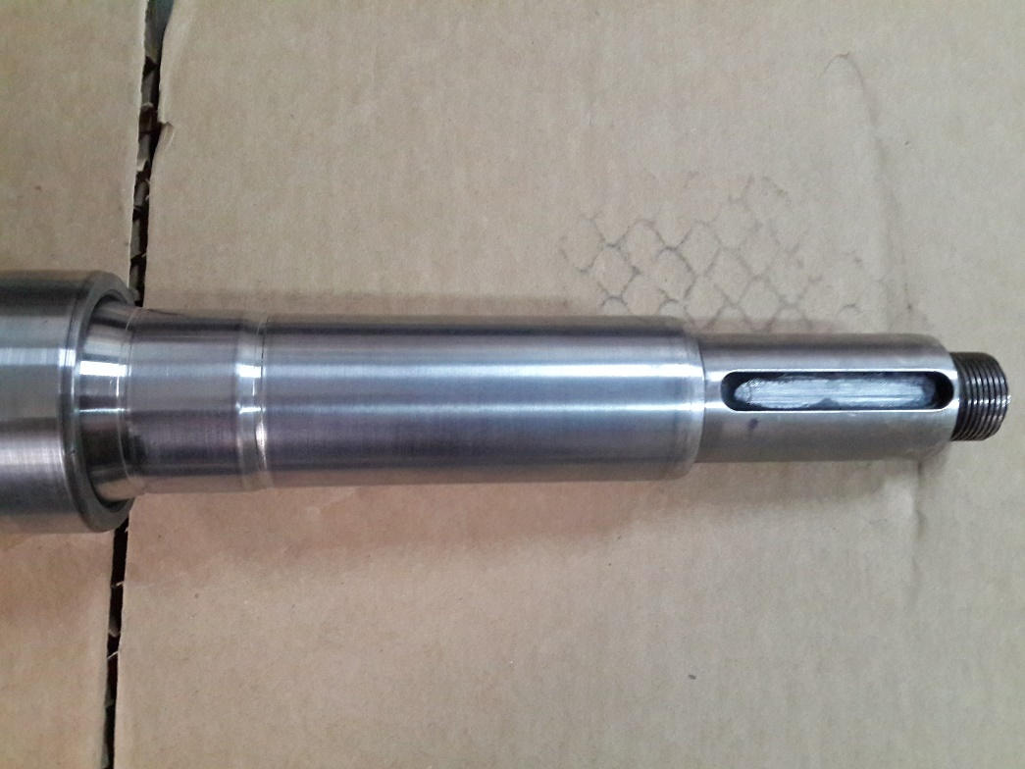**

**Metal Spray to rebuild back dimension**

Agitator Paddles

Paddles are made of 316SS with a Tungsten Carbide coating.

The sprayed Tungsten Carbide will prolong the life of this application up to fourtimes that of any other alloy.

****

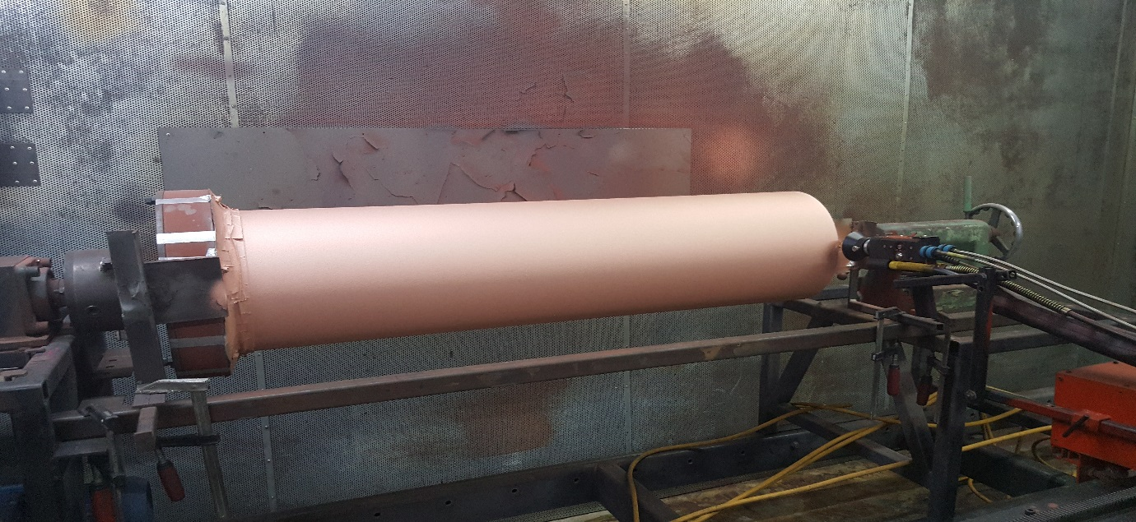

After Arc-Spray coating of Pure copper.

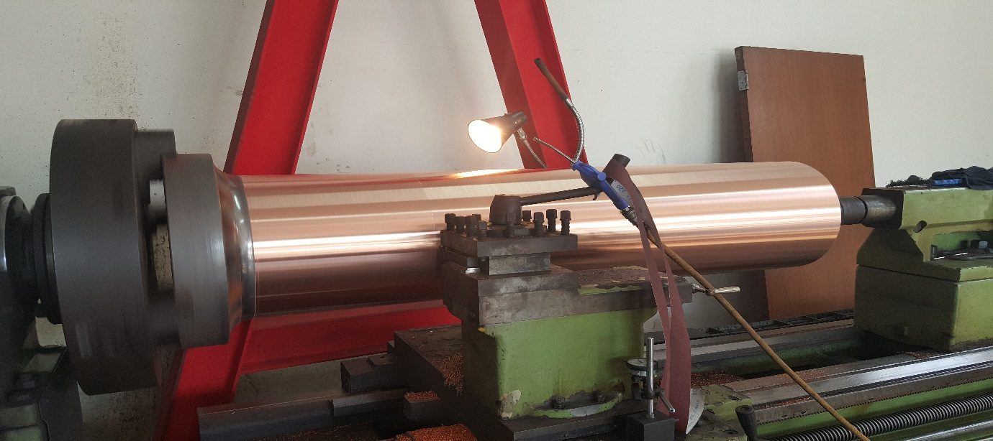

Machining before roller send for chroming

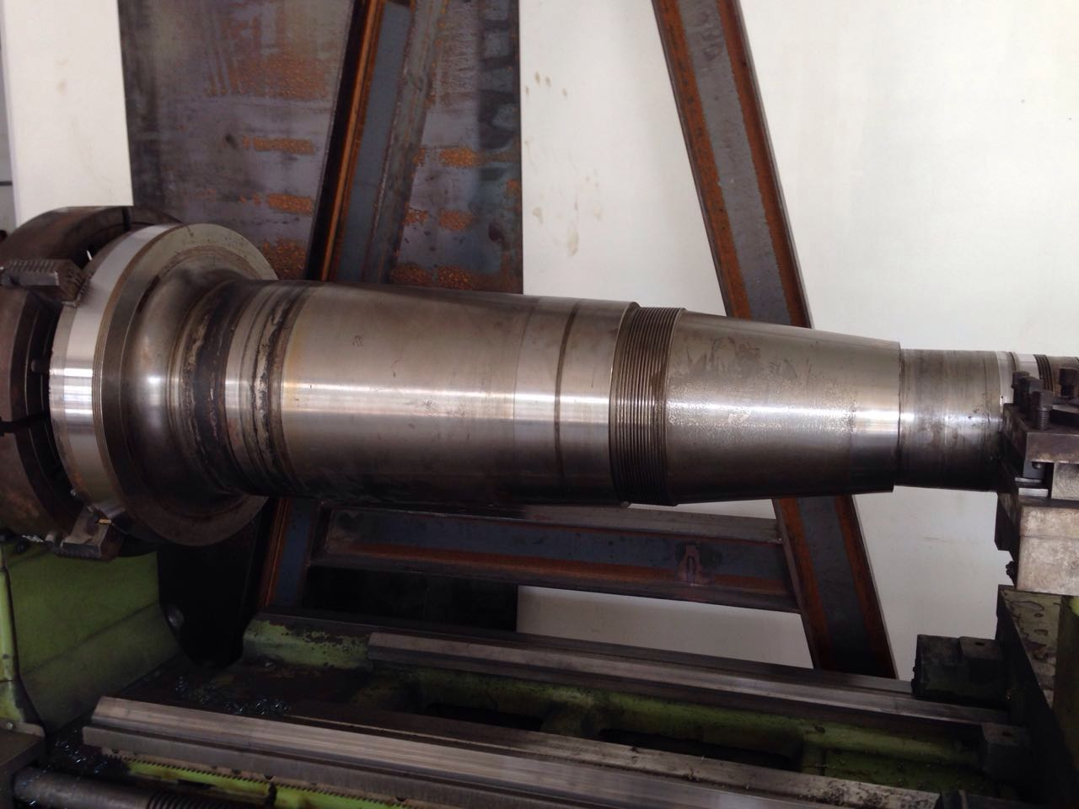

Repair of bearing journal by Arc-Spray

Before spray

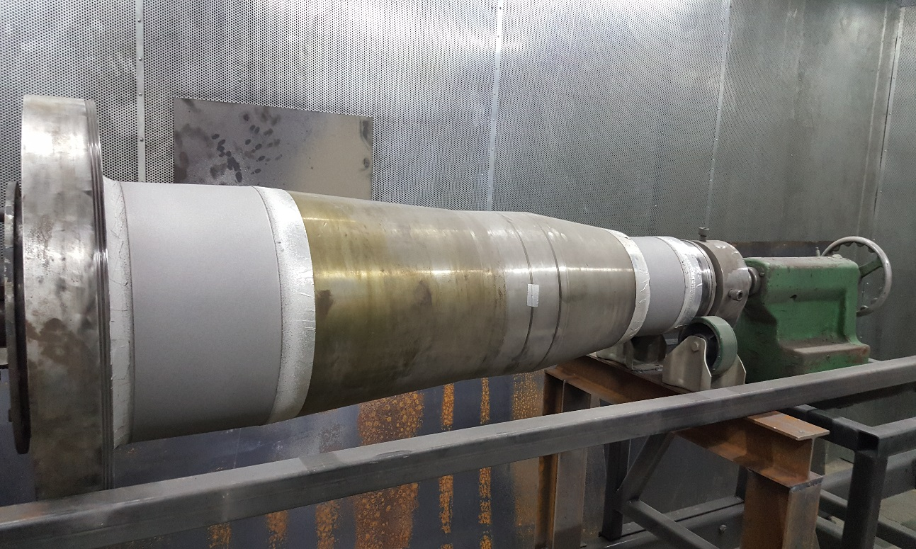

After spray

Close up view before and after repair

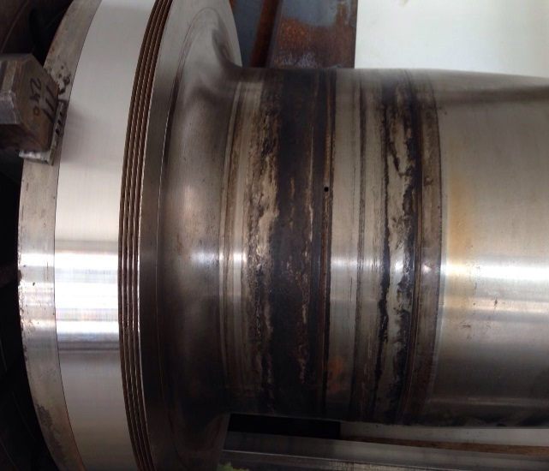

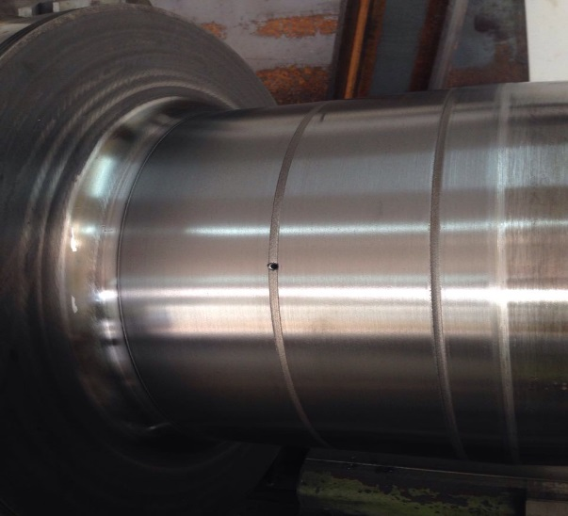

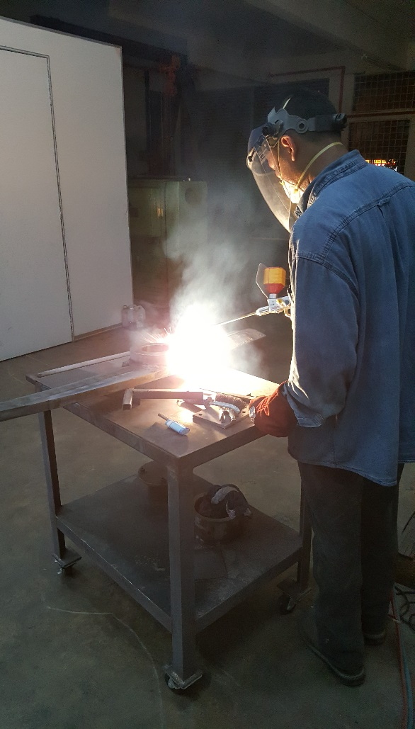

After spray and finishing.

Before repair

Repairing of mixer blade

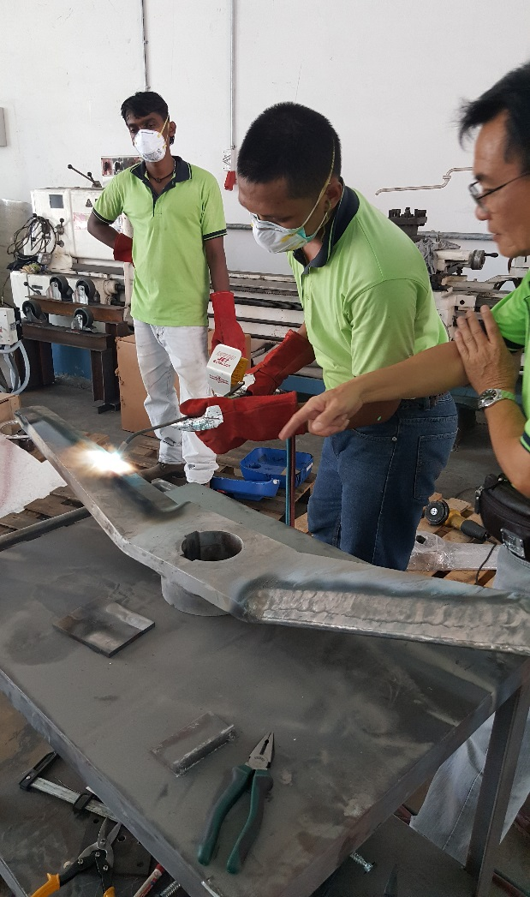

To apply Tungsten Carbide

Coating on Mixer blade

Preheat mixer blade

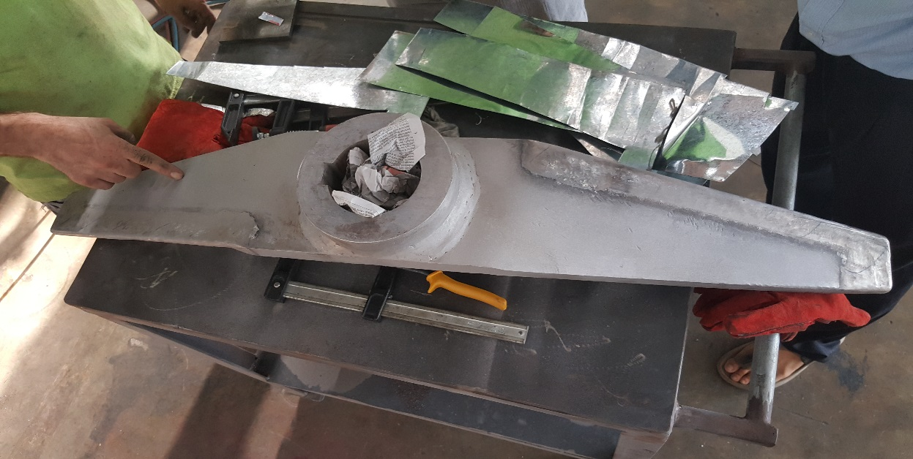

After completion of repair

Refurbishment of compact 60 shaft by Arc spray process.

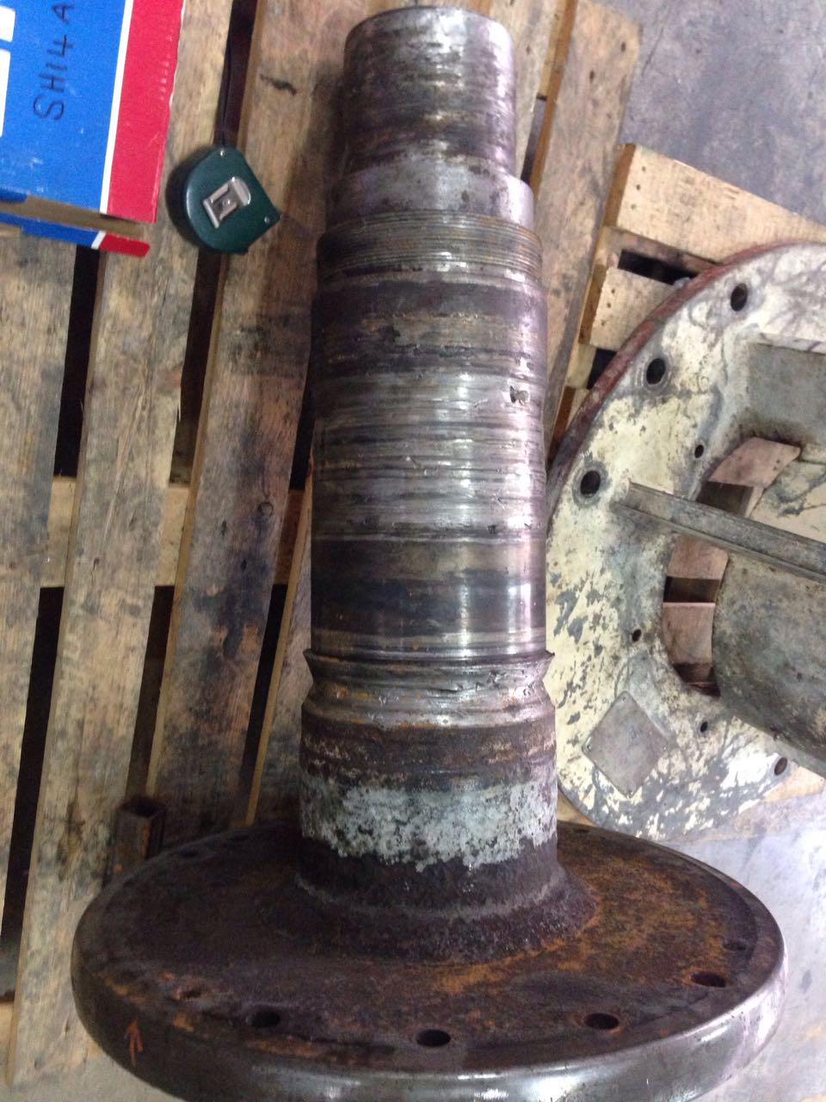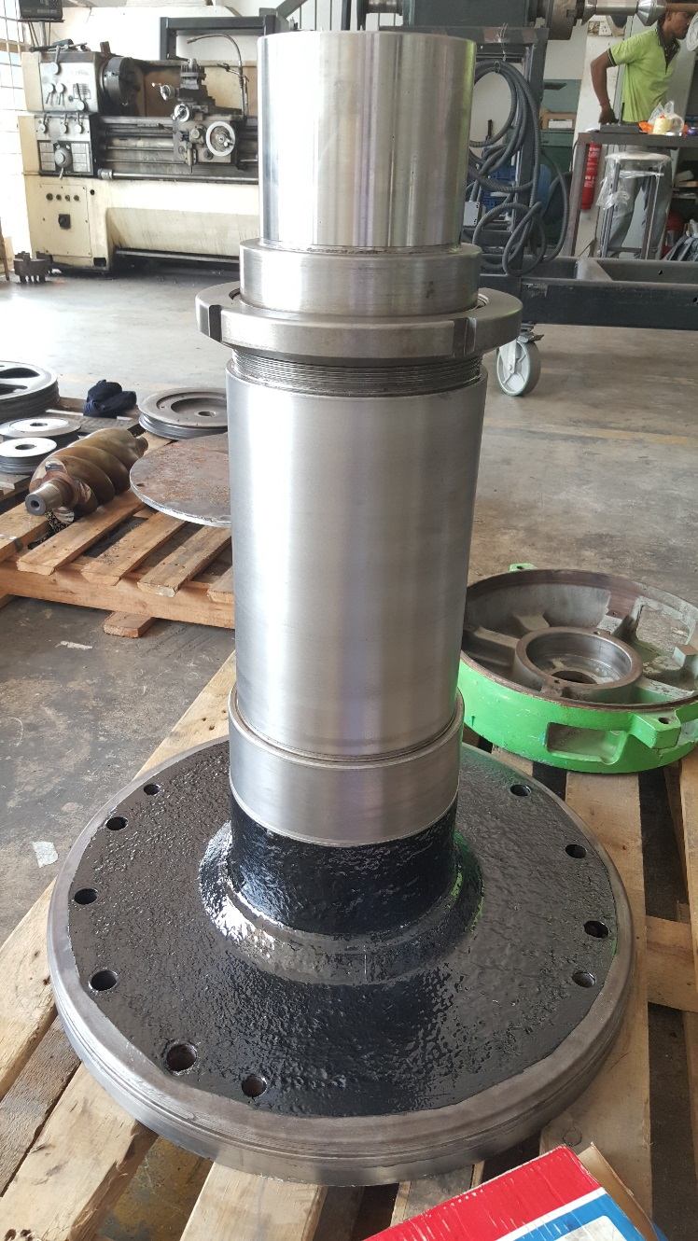

Before repair

After spray and finishing.

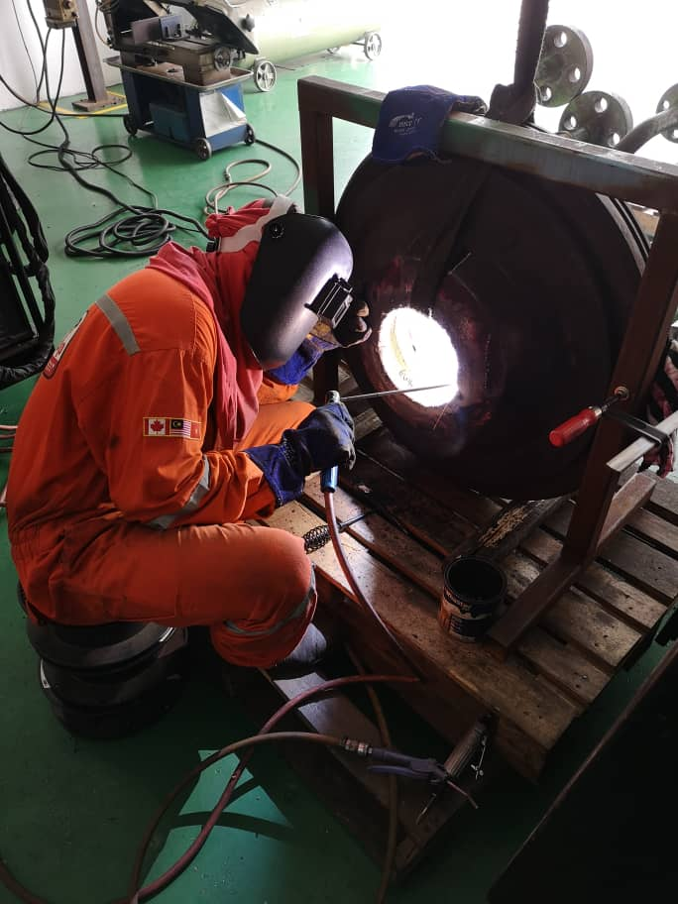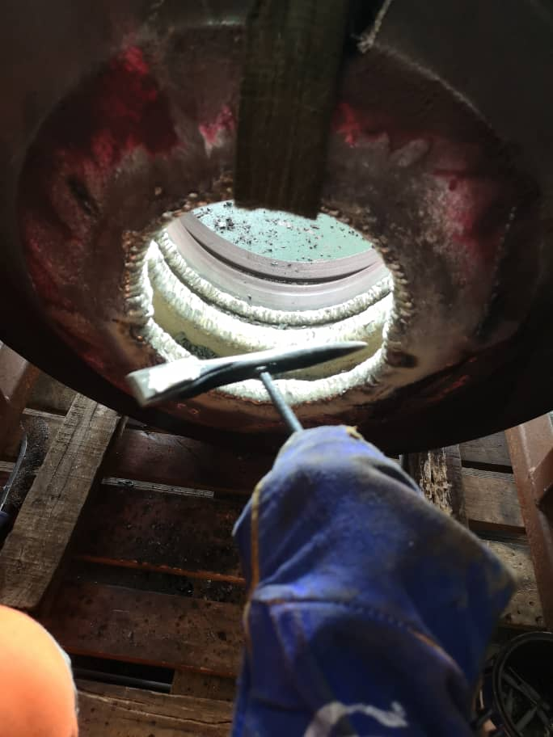

Repairing of labyrinth seat area by SMAW welding. Material Nickle alloy

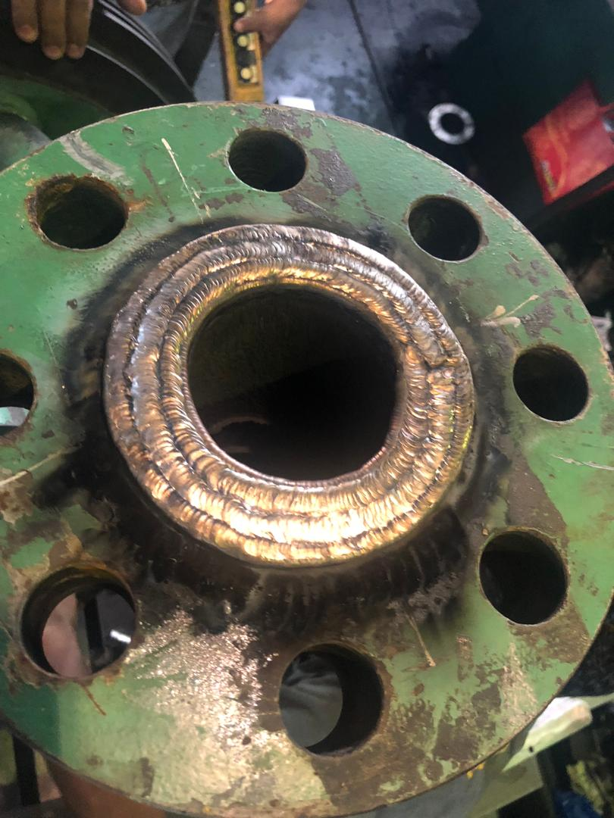

After completion of welding and ready for machining.

To rebuild and repair badly damaged areas on plate cover by using stainless steel welding.

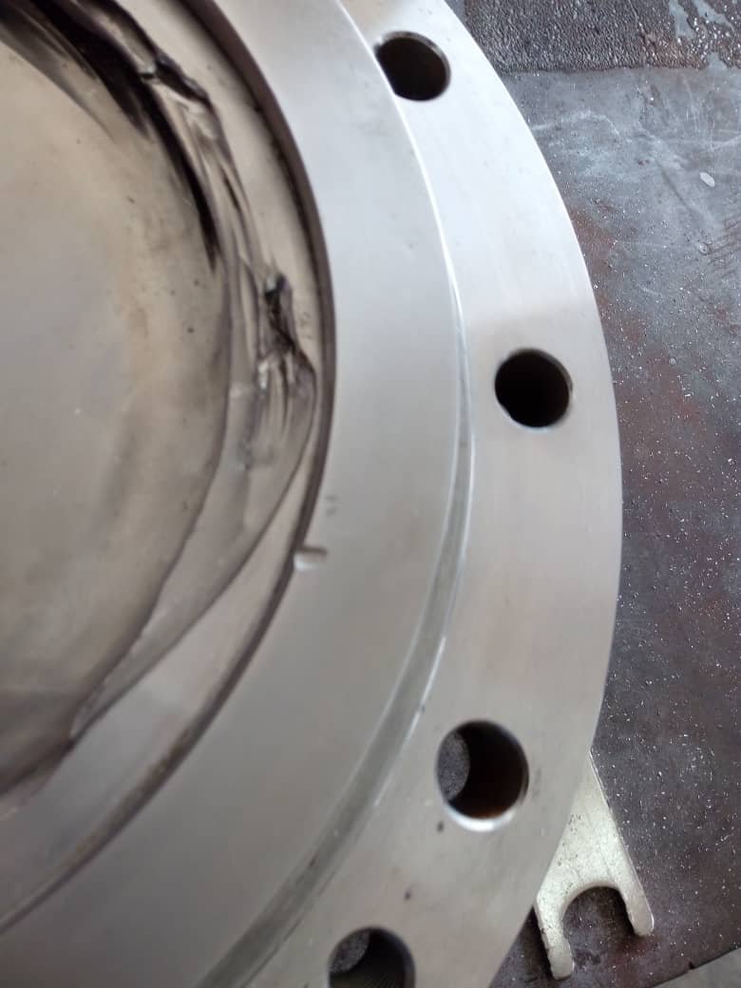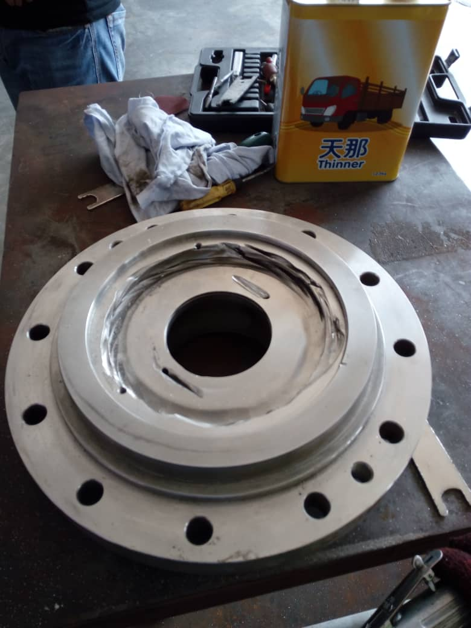

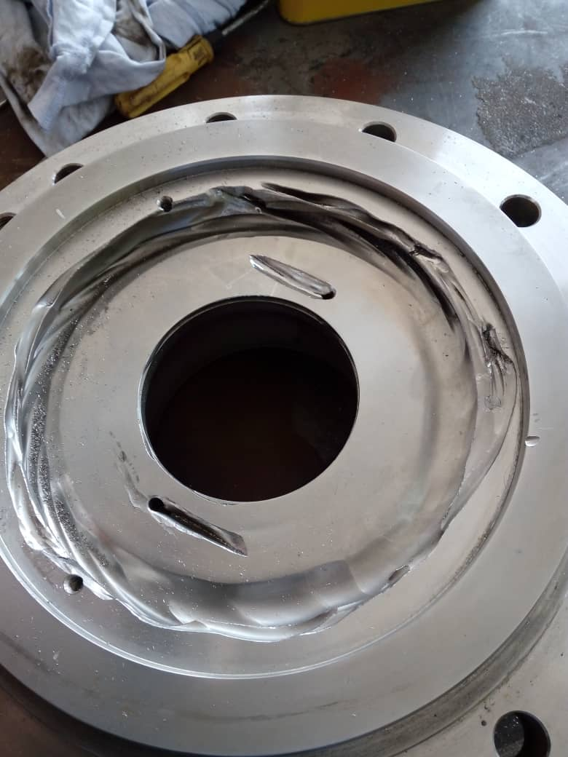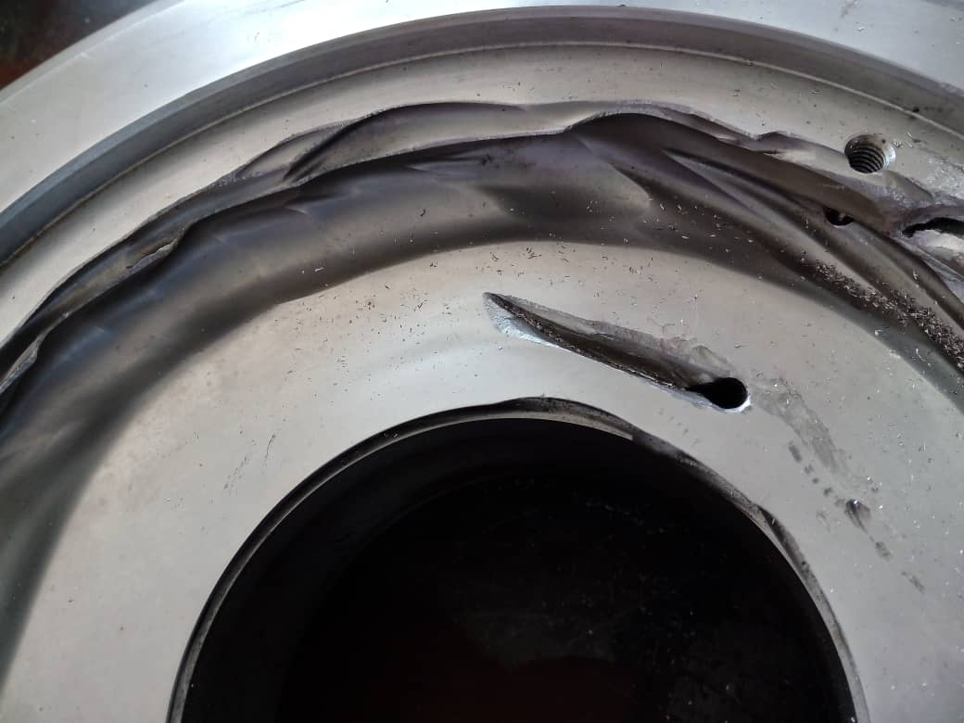

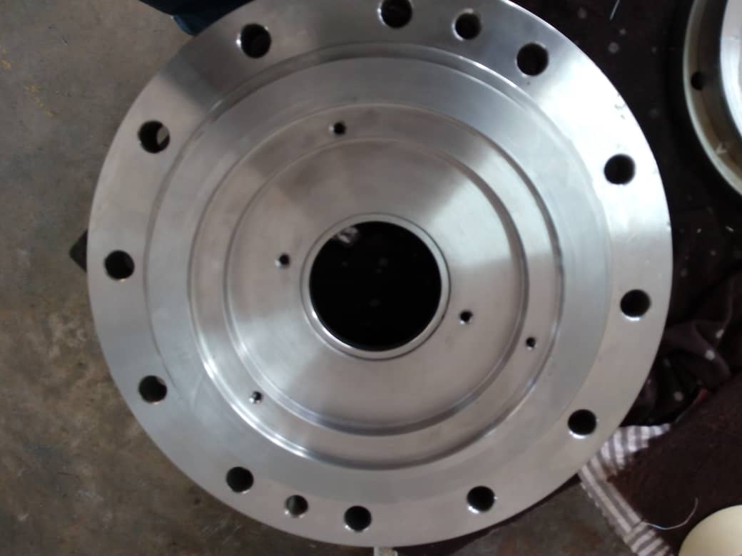

After repair and machine

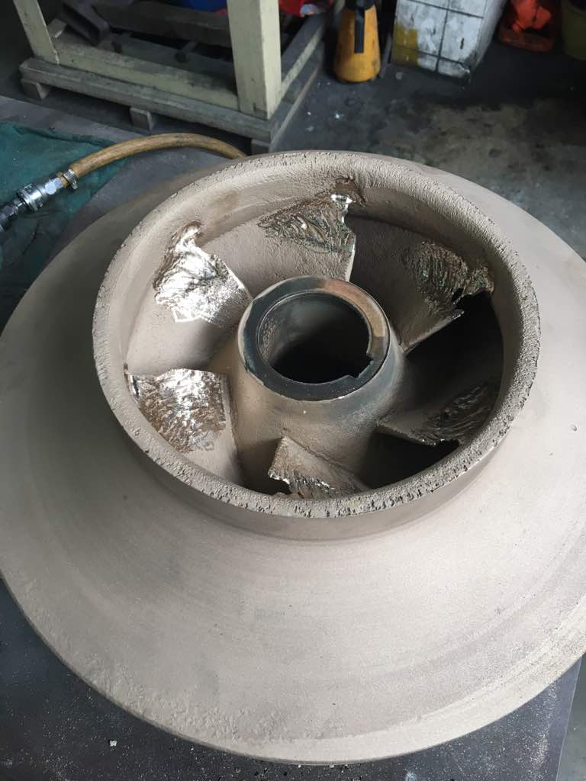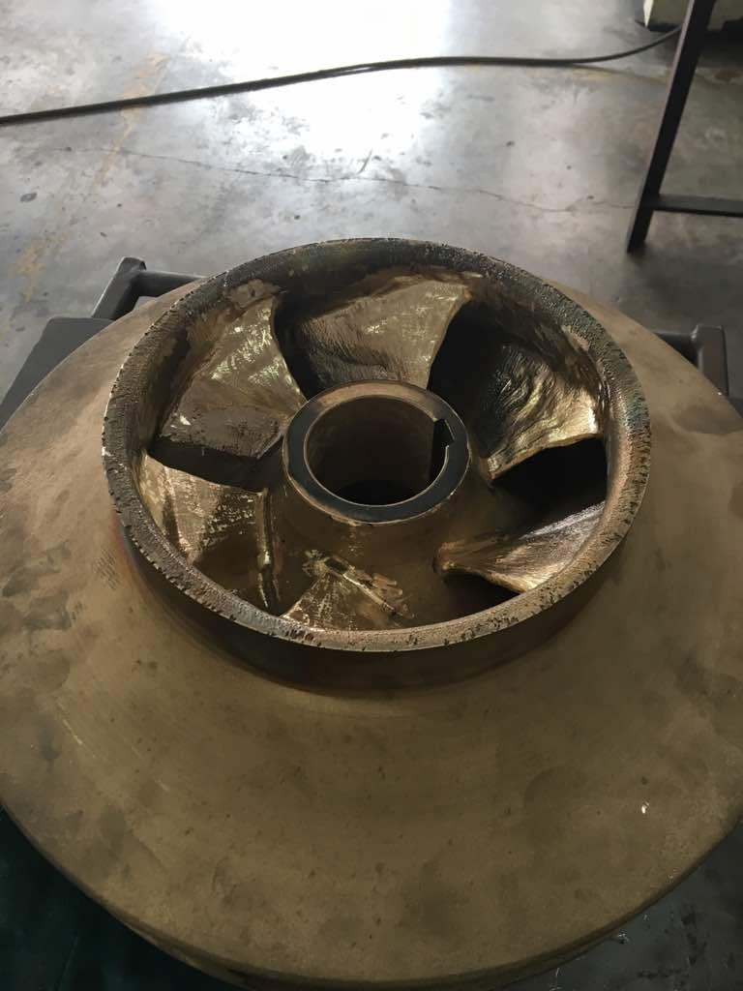

Repairing of impeller vane by bronze welding

Before repair

After repair

To perform laser welding on worn edges of roller

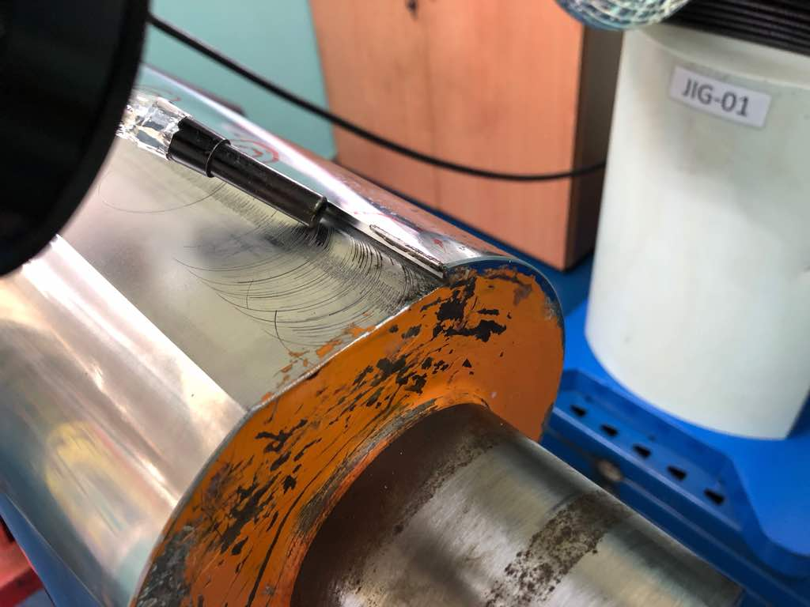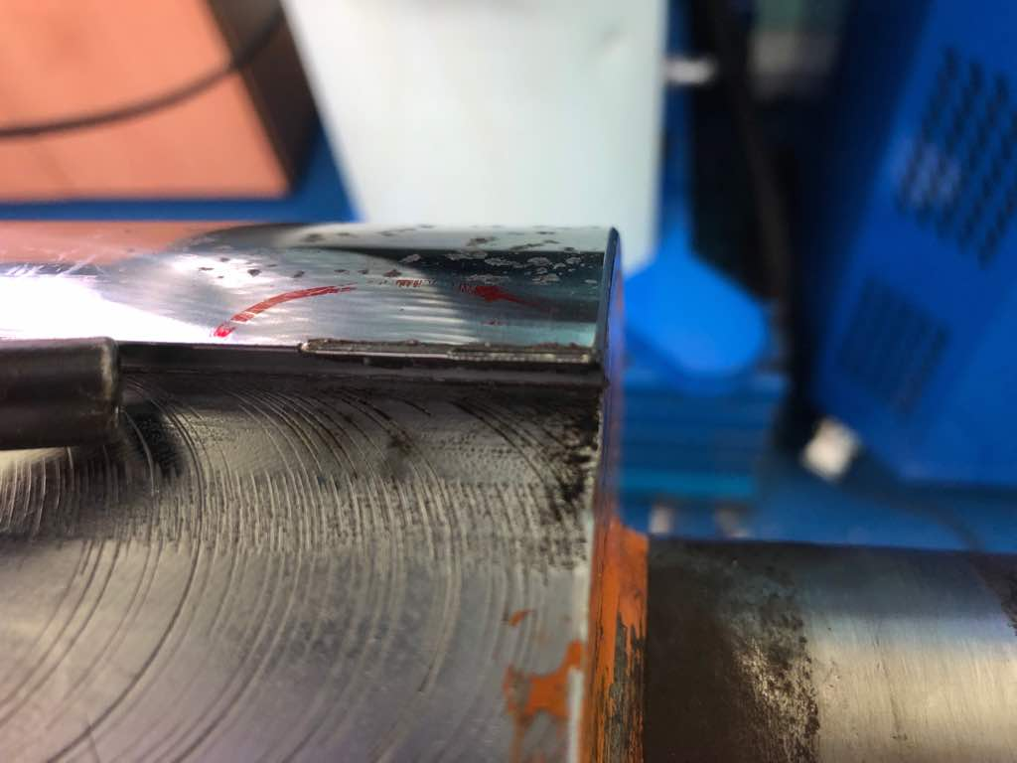

After laser welding repair

Before laser welding repair

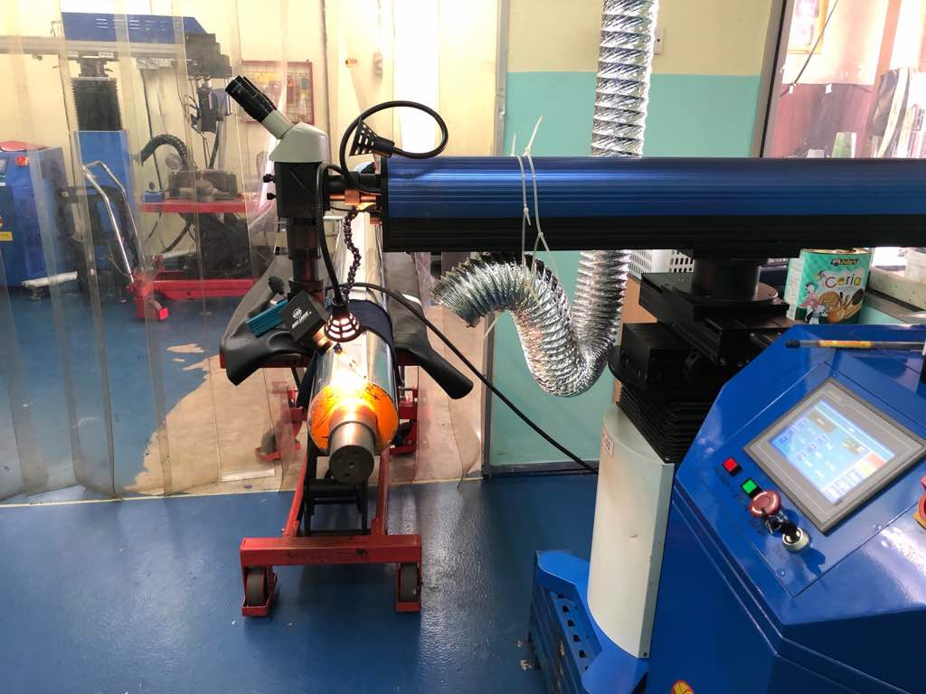

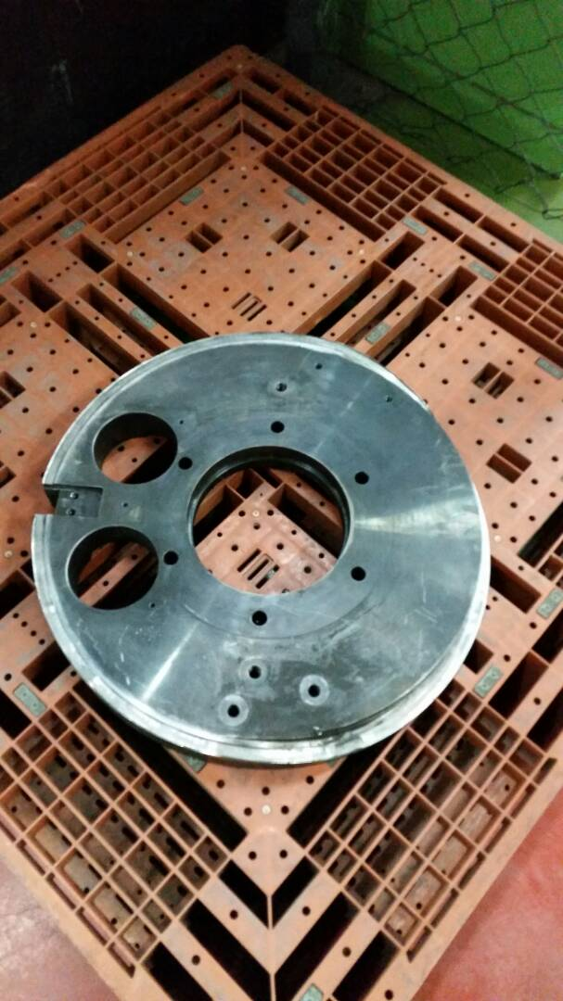

To repair Guide area of turn table

By laser welding.

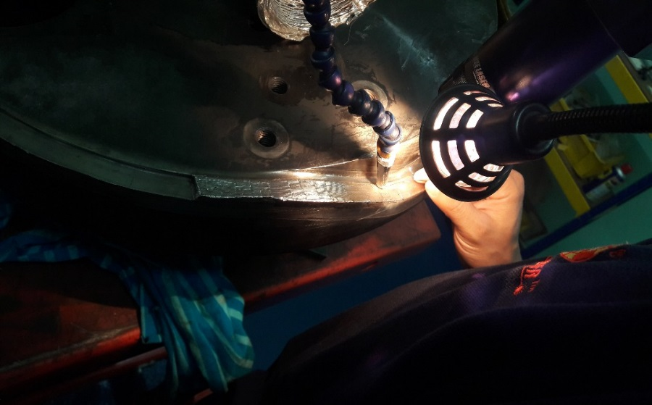

Repairing work on turn table

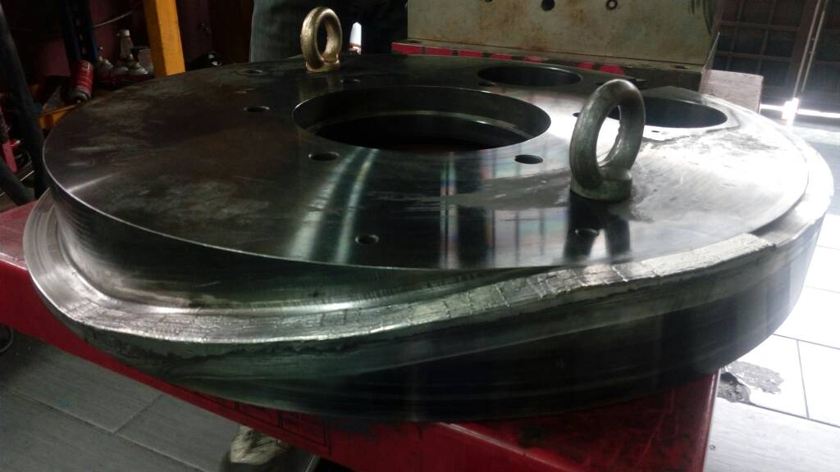

Completion of repair on

Guide area by laser welding

Before sending for final

finishing by CNC Machining.

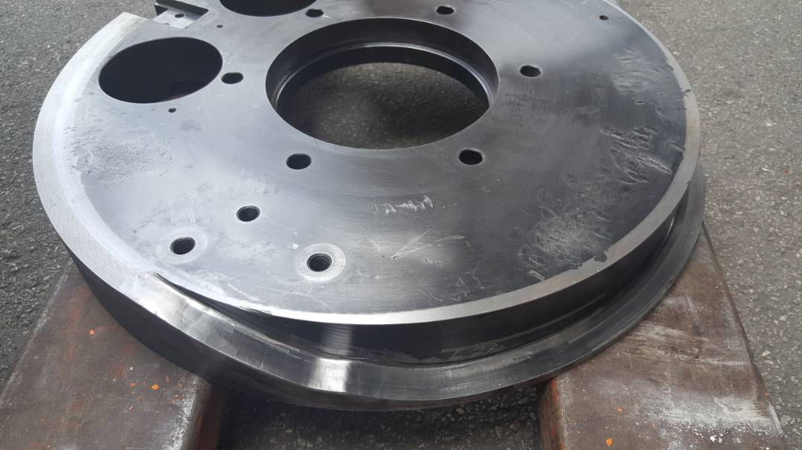

Job completed.

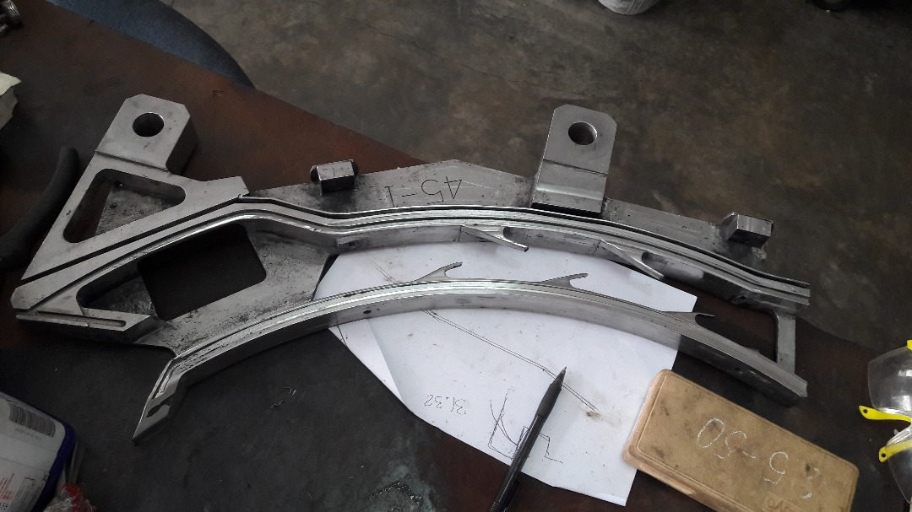

To rebuild low spot area

On shoe feeder by laser

Welding process.

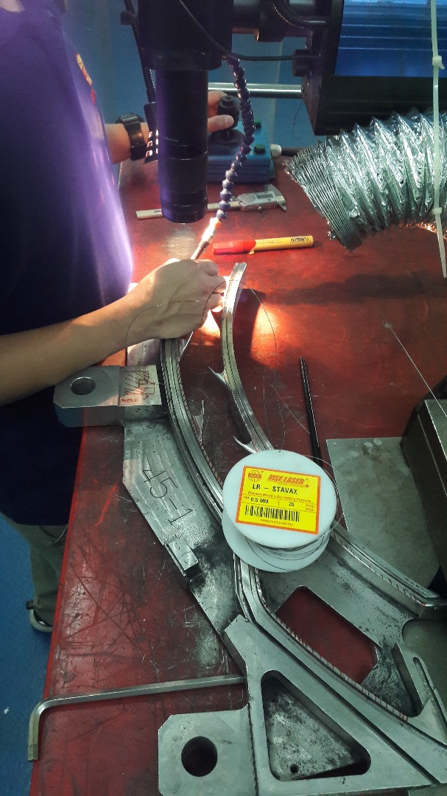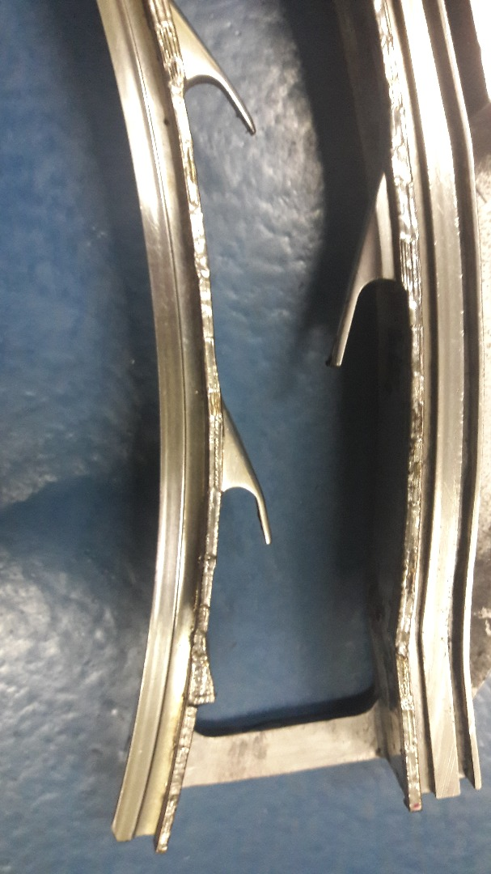

After completion of repair and build up

On shoe feeder by laser welding

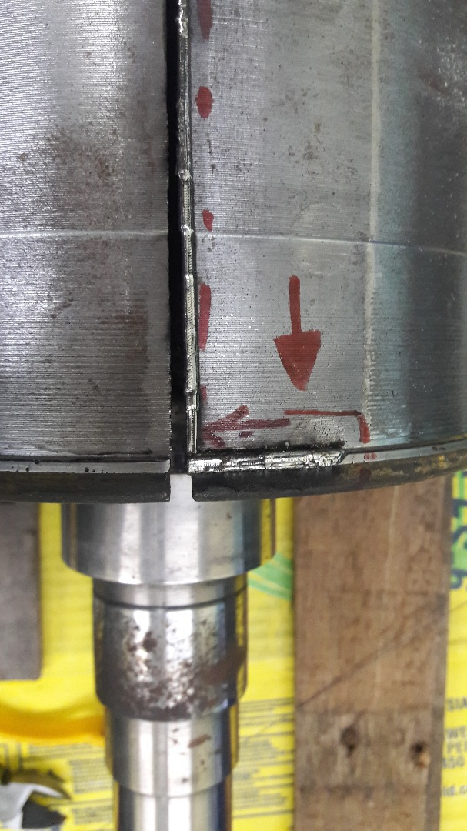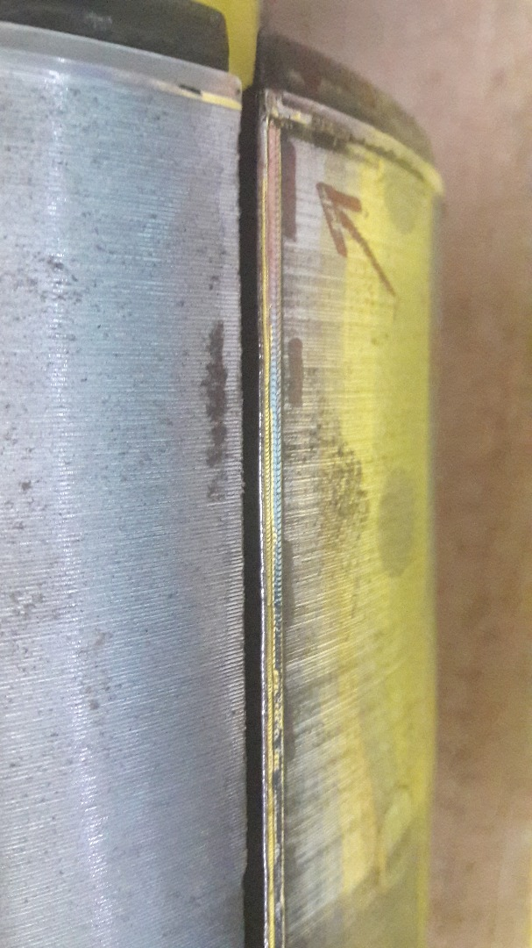

Repairing worn out edge of printing roll by laser welding which is highly recommended when area of weld is sensitive to heat and prone to bending.

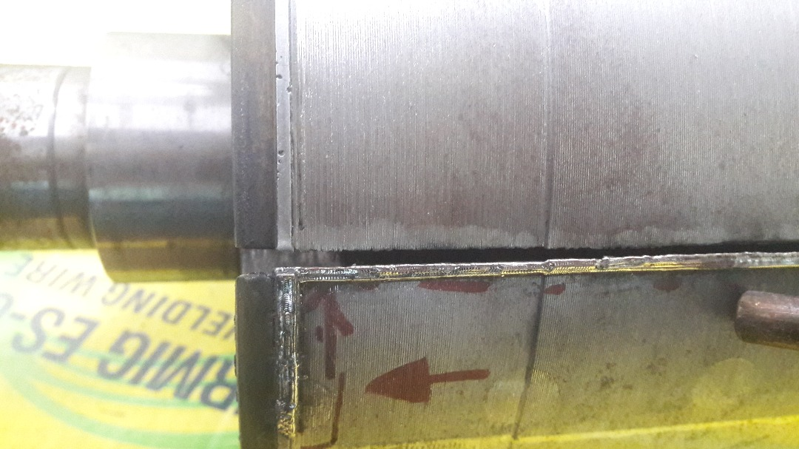

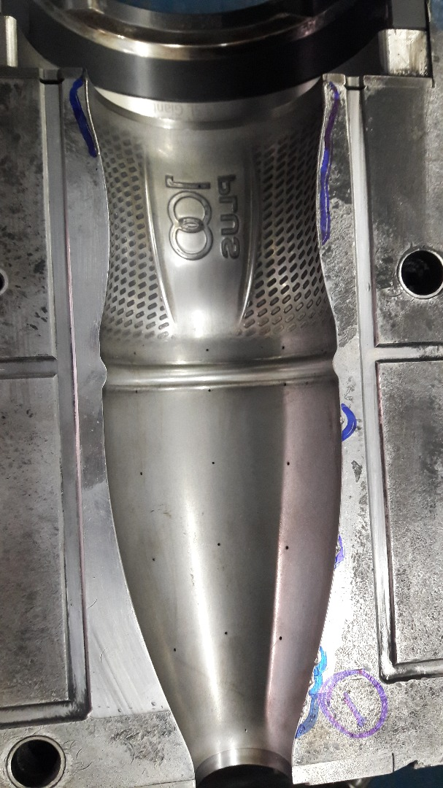

Repairing of mold by laser welding.

**Special repair and joining Welding**

Onsite welding Jobs

Klin Tyre Repair

Sub Industry Focus

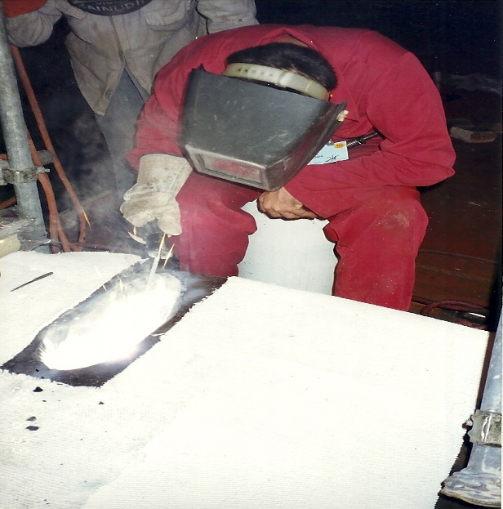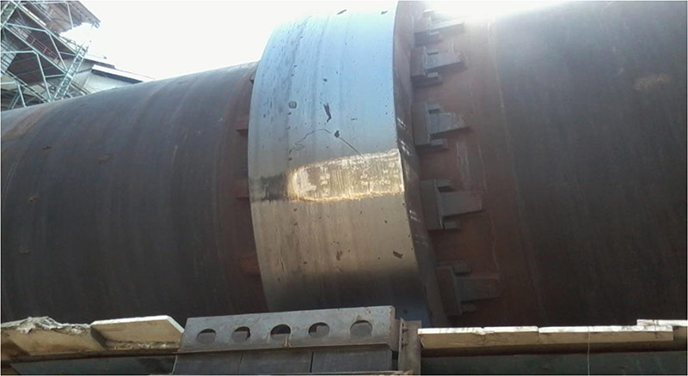

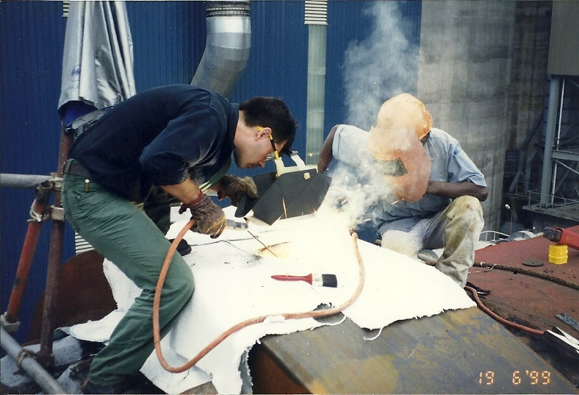

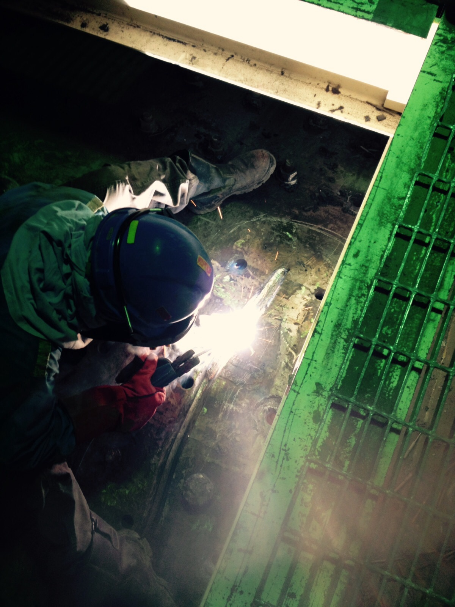Ball Mill Crack Repair

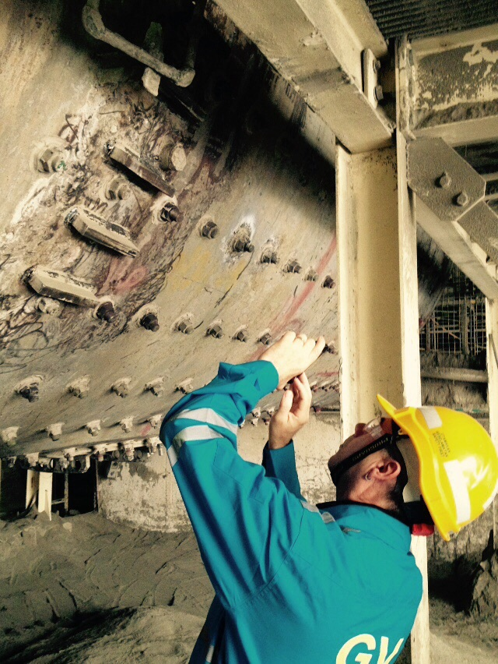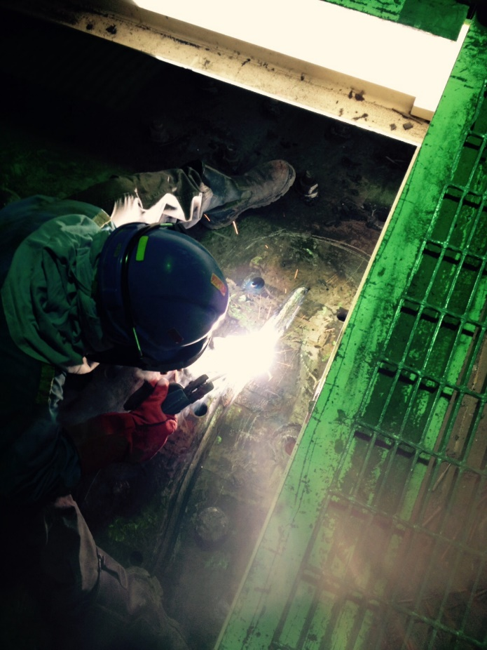

Ball Mill Pinion Gear Repair

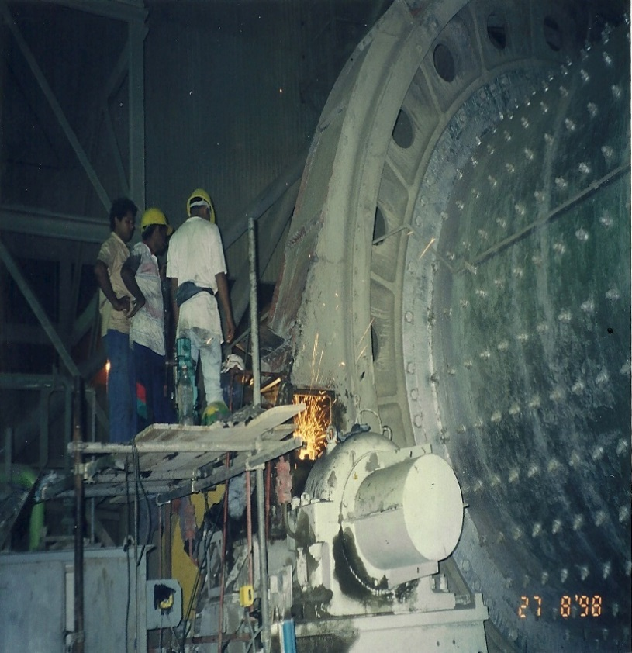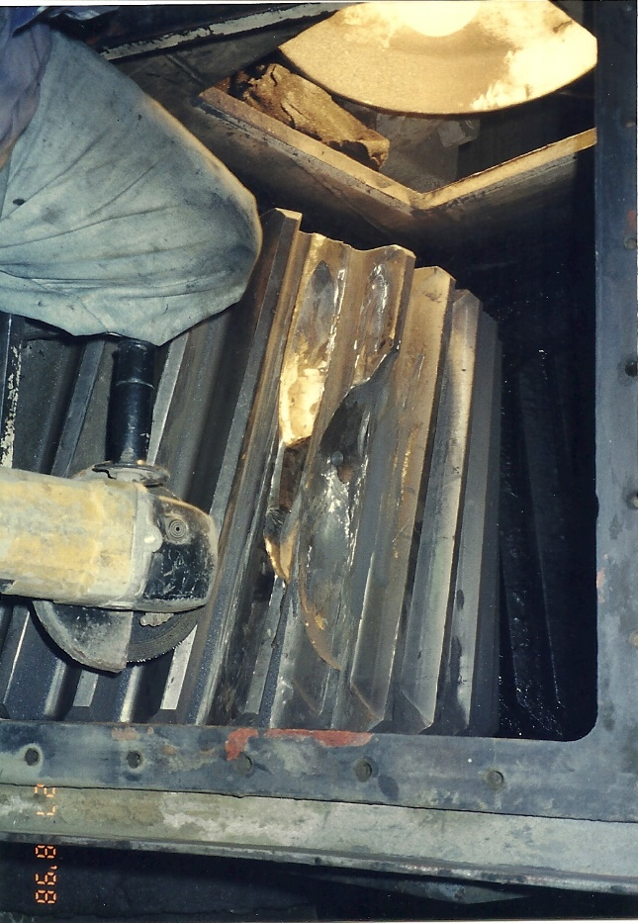

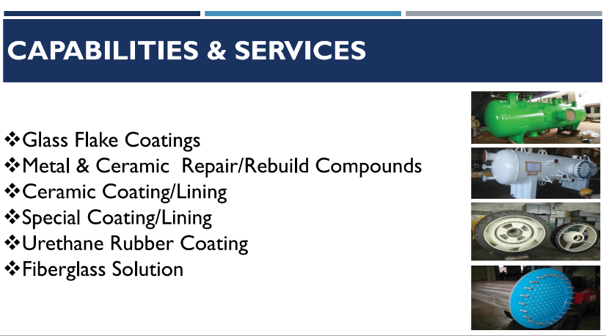

Wet coating Services (picture with Yusri)

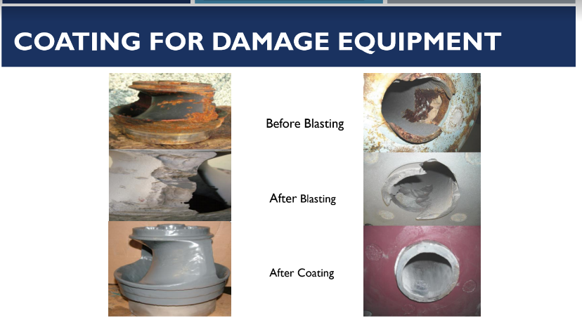

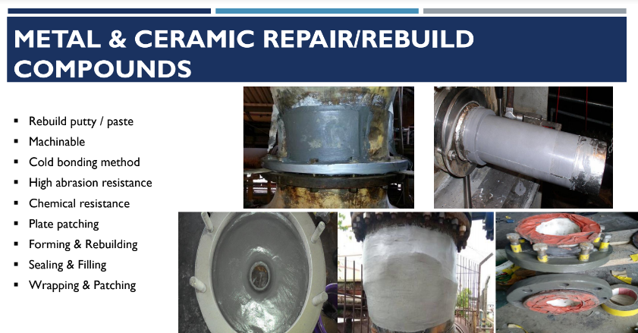

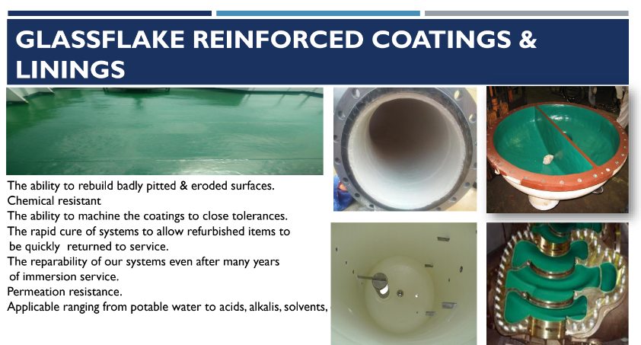

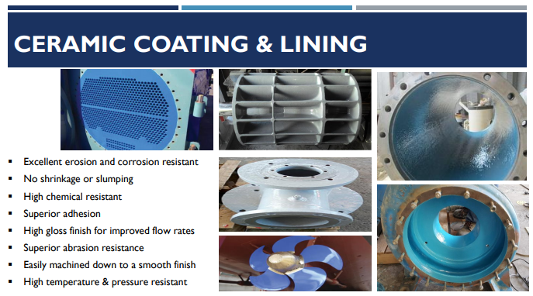

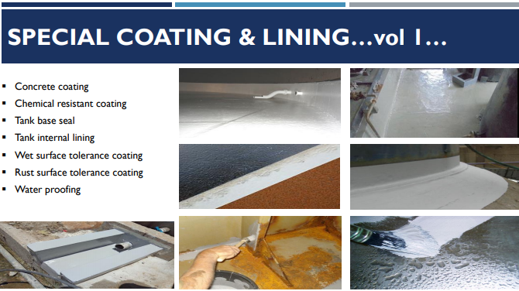

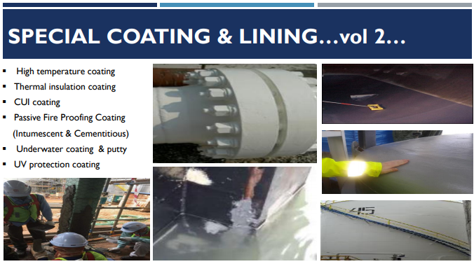

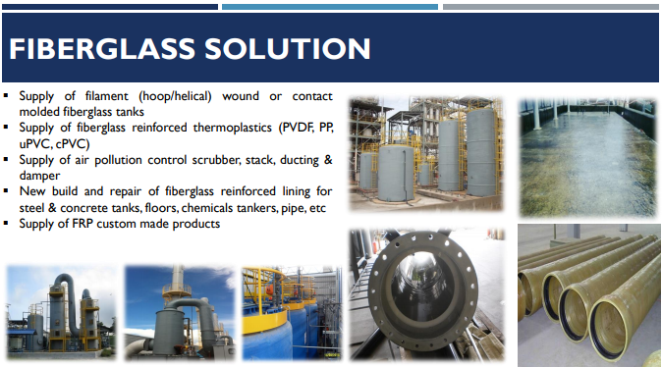

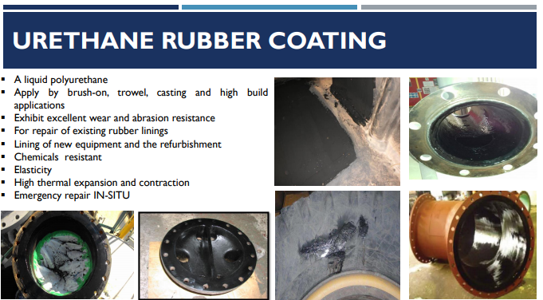

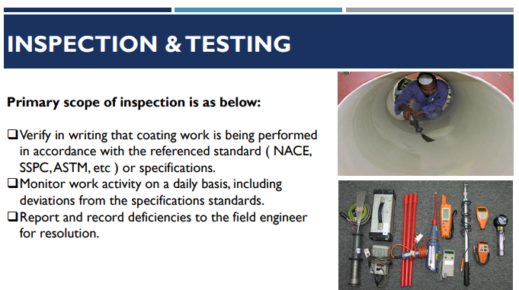

r